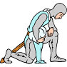
Middle Ages Learning Centers

Miss Ann’s Code of Honor:
* I shall do my best to keep the Learning Centers organized.
* I shall be prepared to answer any questions.
* If I do not know the answer to a question, I shall strive to look for an answer together.
* I shall try my best to help students learn a lot about the Middle Ages!
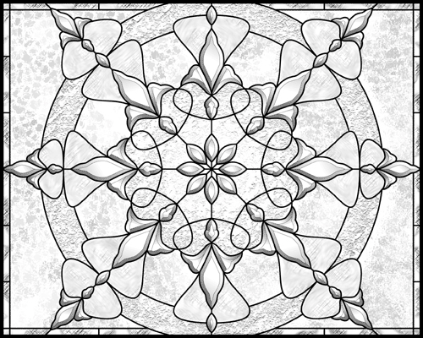
* I shall maintain this noble code of honor, do good unto others, and always be ready to wear my armor for learning!
Signed by Miss Ann on November 13, 2007 . A

__________________’s Code of Honor
Write your name here

* I shall try my very best to complete at least two Middle Ages centers that interest me.

* I shall learn independently and do my best to not distract others and myself.

* I shall work at a Middle Ages Learning Center only after I have finished all of my other classwork.

* I shall sign in to the learning center every time I work at a learning center, and I shall put my packet in my Social Studies folder

* I shall keep all the materials, pictures, and readings organized in each Middle Ages Learning Center.

* If I have a question, I shall quietly ask Mrs. Kaplan, Miss Ann, or a neighbor who is working on the same activity.

* I will be willing to share what I have learned with my class.

* If a certain topic interests me and I want to learn more, I shall talk to Miss Ann or Mrs. Kaplan about how I can find more interesting information.

* I shall try my best to _______________________________________________________________.

* I shall maintain this noble code of honor, do good unto others, and always be ready to wear my armor for learning!

Signed by _____________________________________ on _____________________
Your signature Date

My Seal :

